1. With the basics about routing set, let’s enhance our app a bit by going back to the app module and adding some routes to it. We want to load single user, so to load the user component which simply well gives us that single user. We want to load our user dynamically.
2. 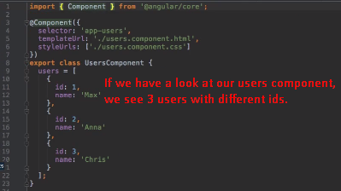
3. It would be nice if we could pass the id of the user we want to load in that route path.
4. One approach would be like the following slide.  
    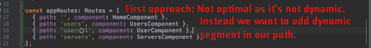
5. We do this by adding :any_name to the path. You would be able to retrieve the parameter inside the loaded component by that name.
6. Colon tells angular that this is dynamic part of the path. 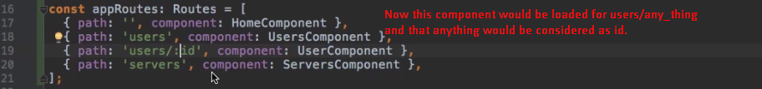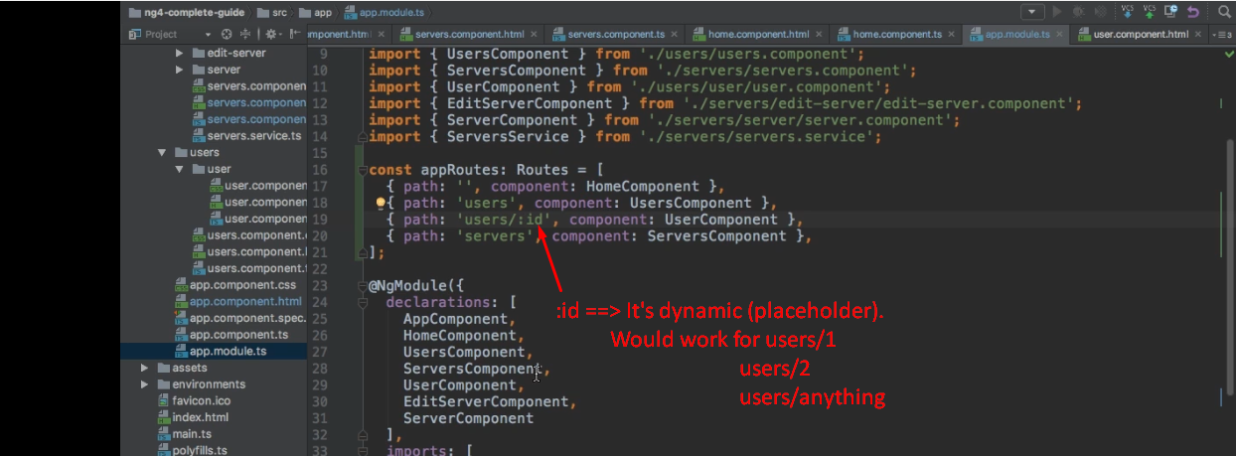
7. 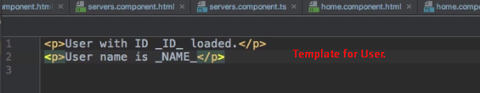
8. 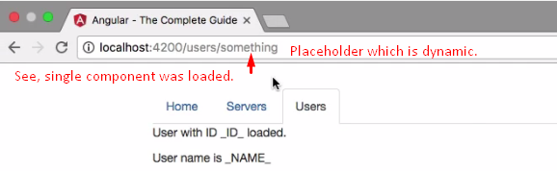
9. 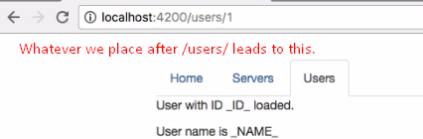
10. So, we learnt how to dynamically load some route using Router.navigate() and how to **encode** some **data into our path**.
11. Let’s see how to get access to this data in the loaded component.